LIBRARY MANAGEMENT SYSTEM
PROJECT DESIGN

Contents
1. Project Brief 3
1.1 Project Title 3
1.2 Problem Statement 3
1.3 Project Objectives 3
1.4 Intended Users 3
1.5 Project Scope 4
1.6 Project Boundaries and Assumptions 4
2. Relational Database Design and Data Dictionary 5
2.1 Categories 5
2.2 Books 5
2.3 Members 6
2.4 Loans 6
3. Entity Relationship Diagram (ERD) 7
3.1 Entities and Attributes 7
3.2 Explanation of Relationships 8
Categories and Books 8
Books and Loans 8
Members and Loans 8
3.3 Why These Relationships Are Necessary 8
4. Relational Schema 8
4.1 Relational Schema Outline 8
4.2 Key Definitions 9
4.3 Referential Integrity and Business Rules 9
4.4 Consistency Between Design Sections 9

1. Project Brief

1.1 Project Title
Design of a Library Management System

1.2 Problem Statement
A library manages books, book categories, registered members, and borrowing and returning activities. When these activities are recorded manually, it may be difficult to track available books, find member information, monitor borrowing dates, and identify overdue books. The proposed Library Management System will organize library information in a relational database. It will help library staff manage book records, organize books into categories, register members, and record book borrowing and returns.

1.3 Project Objectives
The main objective is to design a database system that supports the organized management of library resources and borrowing activities.
- Maintain accurate records of books and their categories.
- Register and manage library members.
- Record book borrowing and returning activities.
- Track due dates and identify overdue books.
- Make it easier to retrieve book, member, and borrowing information.

1.4 Intended Users
User | Responsibilities
Librarian | Manages books, categories, member records, and borrowing transactions.
Library assistant | Records borrowed and returned books and checks borrowing status.
Library member | Borrows and returns books through library staff and may request information about book availability.

1.5 Project Scope
The system will cover four main areas:
- Book management: Store book titles, authors, ISBNs, publishers, publication years, categories, and the number of copies owned.
- Category management: Organize books into categories such as Computing, Science, Business, and Literature.
- Member management: Register members and maintain their contact information and membership status.
- Borrowing and returning: Record which member borrowed which book, when it was borrowed, when it is due, and when it was returned.

1.6 Project Boundaries and Assumptions
- Each book belongs to one category.
- A category can contain many books.
- A member can have many borrowing records.
- Each borrowing record refers to one member and one book.
- A book may appear in many borrowing records over time.
- Each borrowing record represents one copy of a book, not a transaction containing several different books.
- A book's current availability can be calculated from the number of copies owned and the number currently on loan.
- A return date remains empty until the book is returned.
Out of scope: online payments, electronic books, and a complete online member portal.

2. Relational Database Design and Data Dictionary
The proposed database contains four tables: Categories, Books, Members, and Loans.

2.1 Categories
Purpose: Stores the different categories used to classify books.
Field | Data type | Key / rule | Purpose
category_id | INT | PK, AUTO_INCREMENT | Unique category identifier.
category_name | VARCHAR(100) | NOT NULL, UNIQUE | Name of the category.
description | VARCHAR(255) | NULL allowed | Brief description of the category.

Example: category_id = 1, category_name = 'Computing'.

2.2 Books
Purpose: Stores details about each book title and the number of physical copies the library owns.
Field | Data type | Key / rule | Purpose
book_id | INT | PK, AUTO_INCREMENT | Unique book identifier.
category_id | INT | FK, NOT NULL | References Categories category_id.
title | VARCHAR(200) | NOT NULL | Title of the book.
author | VARCHAR(150) | NOT NULL | Author's name.
publisher | VARCHAR(150) | NULL allowed | Publisher's name.
publication_year | SMALLINT | NULL allowed | Year the book was published.
total_copies | INT | NOT NULL, DEFAULT 1 | Total number of copies owned.

Rule: total_copies must be at least 1. Available copies are calculated from active loan records rather than stored separately.

2.3 Members
Purpose: Stores the details of people registered to borrow library books.

Field | Data type | Key / rule | Purpose
member_id | INT | PK, AUTO_INCREMENT | Unique member identifier.
full_name | VARCHAR(150) | NOT NULL | Member's full name.
email | VARCHAR(150) | UNIQUE, NULL allowed | Email address, if supplied.
phone | VARCHAR(20) | NULL allowed | Contact telephone number.
address | VARCHAR(255) | NULL allowed | Member's address.
registration_date | DATE | NOT NULL | Date of registration.
status | VARCHAR(20) | NOT NULL, DEFAULT 'Active' | Membership status, e.g. Active or Inactive.

Rule: member IDs are generated automatically. Email addresses must be unique when provided.

2.4 Loans
Purpose: Stores every borrowing transaction and its return information.
Field | Data type | Key / rule | Purpose
loan_id | INT | PK, AUTO_INCREMENT | Unique loan identifier.
book_id | INT | FK, NOT NULL | References Booksbook_id.
member_id | INT | FK, NOT NULL | References Members member_id.
borrow_date | DATE | NOT NULL | Date the book was borrowed.
due_date | DATE | NOT NULL | Date the book should be returned.
return_date | DATE | NULL allowed | Actual return date; NULL means not yet returned.
status | VARCHAR(20) | NOT NULL, DEFAULT 'Borrowed' | Status such as Borrowed, Returned, or Overdue.

- due_date must be on or after borrow_date.
- return_date remains empty until the book is returned.
- A loan can only reference an existing book and member.
- The system must not allow more copies to be borrowed than the library owns.
- Overdue status can be calculated from the due date and return date. If status is stored, it must be updated consistently.

3. Entity Relationship Diagram (ERD)
The ERD contains four entities and shows the primary keys, foreign keys, and relationships between them.
ERD structure
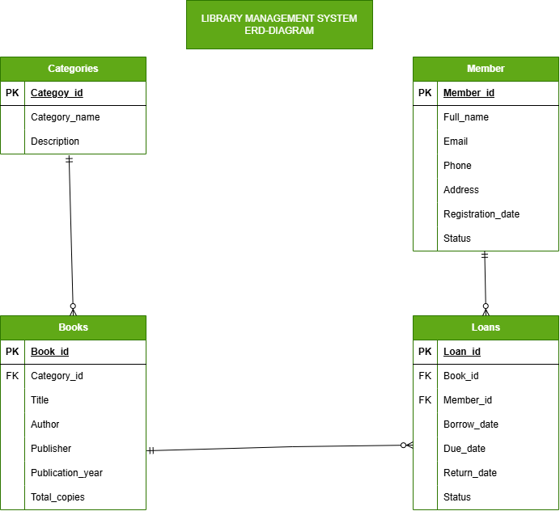

3.1 Entities and Attributes
- CATEGORIES: category_id (PK), category_name (UNIQUE), description
- BOOKS: book_id (PK), category_id (FK), title, author, publisher, publication_year, total_copies
- MEMBERS: member_id (PK), full_name, email (UNIQUE), phone, address, registration_date, status
- LOANS: loan_id (PK), book_id (FK), member_id (FK), borrow_date, due_date, return_date, status

3.2 Explanation of Relationships

Categories and Books
One category can contain zero or many books. Each book must belong to exactly one category. Cardinality: one-to-many (1:M). Foreign key: Bookscategory_id.

Books and Loans
One book can have zero or many loan records over time. Each loan record refers to exactly one book. Cardinality: one-to-many (1:M). Foreign key: Loansbook_id.

Members and Loans
One member can have zero or many loan records. Each loan record belongs to exactly one member. Cardinality: one-to-many (1:M). Foreign key: Loansmember_id.

3.3 Why These Relationships Are Necessary
The Categories table prevents category details from being repeated for every book. The Books table stores book information separately from borrowing transactions. The Members table stores each member's information once, while the Loans table connects members to books whenever borrowing takes place. For example, if a member borrows three books on different occasions, the member is stored once in Members while each borrowing activity receives its own record in Loans. This structure reduces unnecessary data duplication and makes it easier to retrieve borrowing history.
PK = Primary Key; FK = Foreign Key; UNIQUE = Unique constraint. One-to-many (1:M) means one parent record may be related to many child records. A child record must reference exactly one parent record where the foreign key is NOT NULL.

4. Relational Schema
The relational schema presents the database tables in compact form and identifies their primary and foreign keys.

4.1 Relational Schema Outline
- CATEGORIES (category_id PK, category_name UNIQUE, description)
- BOOKS (book_id PK, category_id FK → CATEGORIEScategory_id, title, author, publisher, publication_year, total_copies)
- MEMBERS (member_id PK, full_name, email UNIQUE, phone, address, registration_date, status)
- LOANS (loan_id PK, book_id FK → BOOKSbook_id, member_id FK → MEMBERSmember_id, borrow_date, due_date, return_date, status)

4.2 Key Definitions
Term | Definition
Primary key (PK) | Uniquely identifies each row in a table.
Foreign key (FK) | References a primary key in another table to establish a relationship.
UNIQUE constraint | Prevents duplicate values in a field, subject to the database's handling of NULL values.
NOT NULL | Requires a value to be supplied.
AUTO_INCREMENT | Automatically generates a new identifier for a record in MySQL.

4.3 Referential Integrity and Business Rules
- A book cannot reference a category that does not exist.
- A loan cannot reference a nonexistent book or member.
- A category or book referenced by existing records should not be deleted without an appropriate restriction or carefully defined deletion policy.
- Borrowing records should be retained so that the library can review historical activity.

4.4 Consistency Between Design Sections
The project brief describes books, categories, members, and borrowing activities. The data dictionary defines the fields, data types, keys, and constraints for all four tables. The ERD shows the entities and relationships, and the relational schema matches the ERD. Foreign keys connect the correct tables, and the design includes borrowing dates, due dates, and return dates.

Editing note: This document is an editable draft. Replace the cover-page placeholders with your details, review the assumptions with your lecturer's instructions, and insert a formal ERD image if your submission requires a graphical diagram.

